WebDev Club

# Week 1 Report

This is the first week of the WebDev club. The leaders, Samarth, Tharun and Ruthwik, gave an introduction to what exactly the club did, does and will do. It has been told that the club is student centric and so the students started to give their opinions on what they thought the club was about. The club members were asked to introduce themselves and were encouraged to share what they wanted to learn from the club, what they knew and what they would like the club to do.

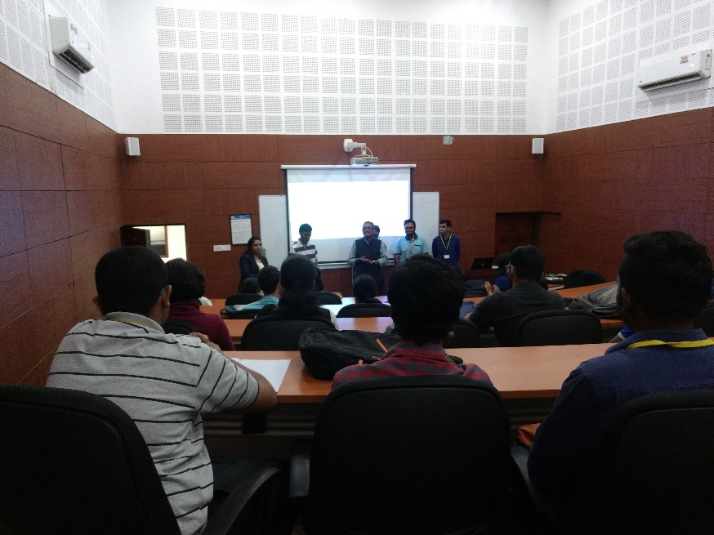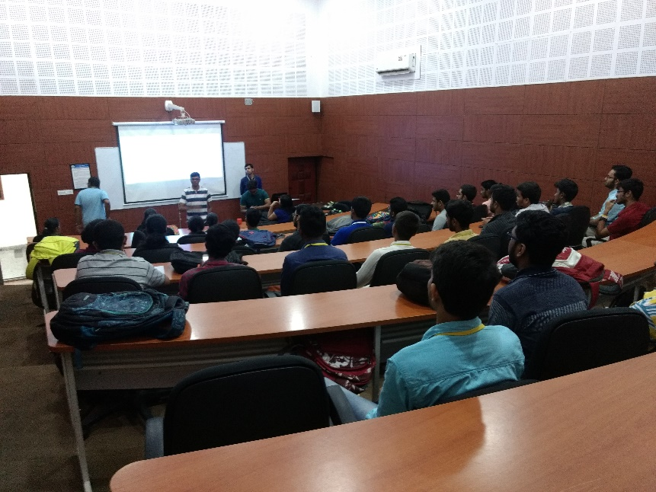We were then greeted by Dr. Krishnan, whose esteemed presence helped us to encourage the club members to choose this club to teach them about web development. Sir also proceeded to give a small talk about the real world applications of web development. Sir then proceeded to thank Raghav, one of the previous club leaders and handed the club onto the current WebDev leaders.

Dr. Krishnan’s talk to the club members

The WebDev leaders introducing the club